|  |  |  |  |  |  |
| --- | --- | --- | --- | --- | --- |
| **Module No:** | 8 | **IU No:** | 3 | **Exercise No.** | 3 |

**Name : Ida Bagus Ketut Yoghantara**

|  |  |
| --- | --- |
| **Lab Assessment Statement** | **Assignment 3 - Build a simple site**  **Referring to Assignment-1's Project Scenario,**  The scope of this assignment is to develop a simple site with rich content creation like a real-world web application development. Initially, our "Online News Portal" site is a blank place so we need to create content and dynamic functionality in pages.  In this assignment, you can free to develop whatever content you like, and are free to determine the layout that you believe will work best for the page.  This is a sample of what the final result should look like. The coloring can differ based on the theme you select.  HOME PAGE  NEWS PAGE  CONTACT US PAGE  ABOUT US PAGE  These are the steps provided to build a site. Some step provides the screenshot to get the desired result.   1. Firstly, Use Liferay's WCM feature to create web content.  * Create three content for news. * Use documents and Media features to upload news photo. * Create two contents for "About us" and "Contact Us". * For About Us and Contact Us page, add the necessary HTML to implement the layout.      1. Create two blog posts with embed videos by using blog Feature.      1. Create new “Application Display Template - ADT” developed with *Velocity* or *Free Marker Template* and enable it for changing the blog posts display dynamically.      1. Create "Page Template" with "Web Content" portlet.      1. Apply Page Template in About us and Contact us Pages.      1. Adding an application portlet into Home, News, About Us and Contact Us pages. 2. Update your "welcome" and other portlet design via from Look and Feel tab.   **Provide caption and screenshots for each step.**  **Provide screen capture of final result pages.** |
| **Technical Environment** | - |
| **Guidelines** | - |
| **Duration** | 120 mins |

1. Firstly, Use Liferay's WCM feature to create web content.

* Create three contents for news.
* Use documents and Media features to upload news photo.
* Create two contents for "About us" and "Contact Us".
* For About Us and Contact Us page, add the necessary HTML to implement the layout.

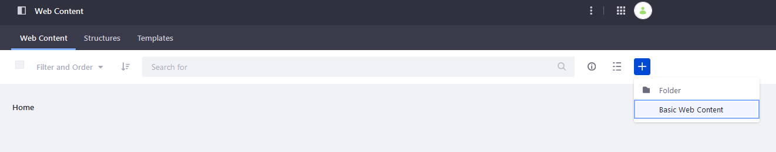  
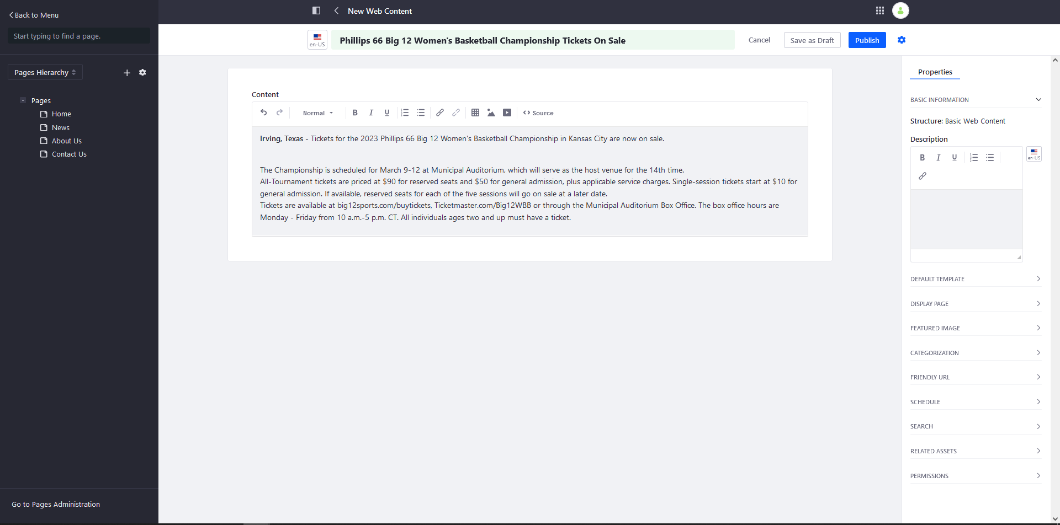  
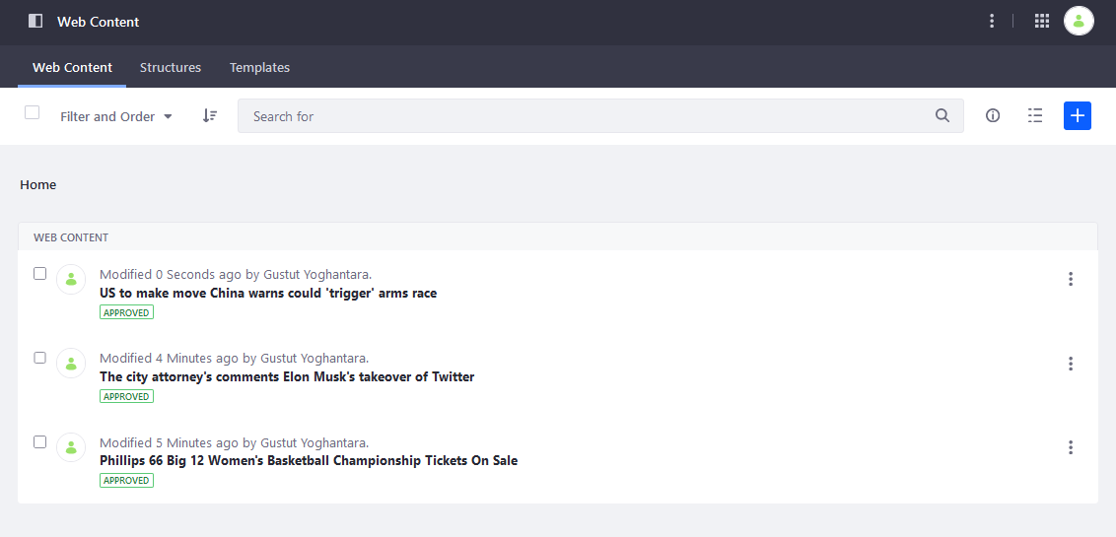

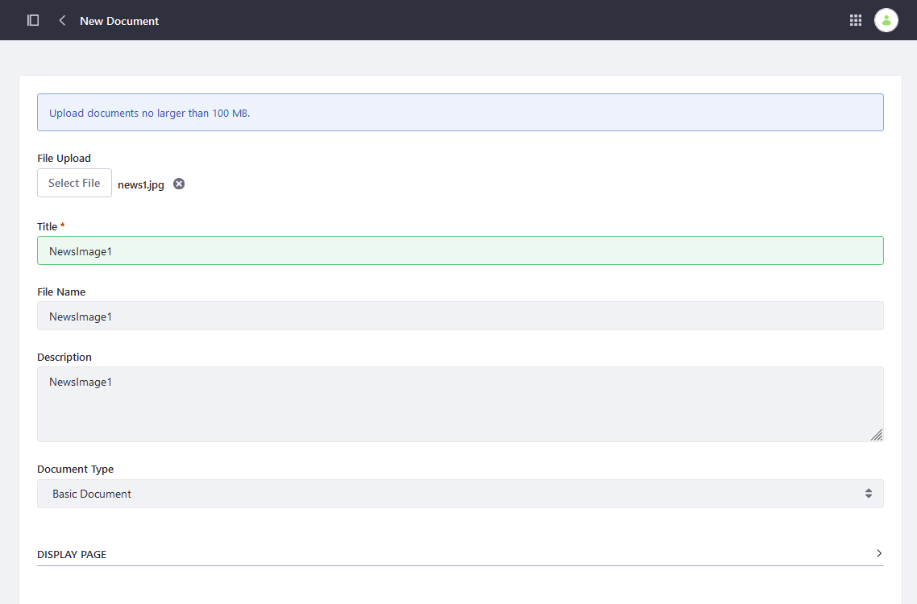

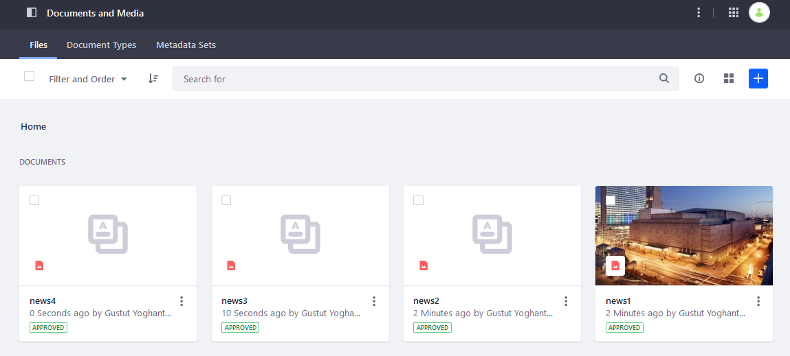  
**About Us**

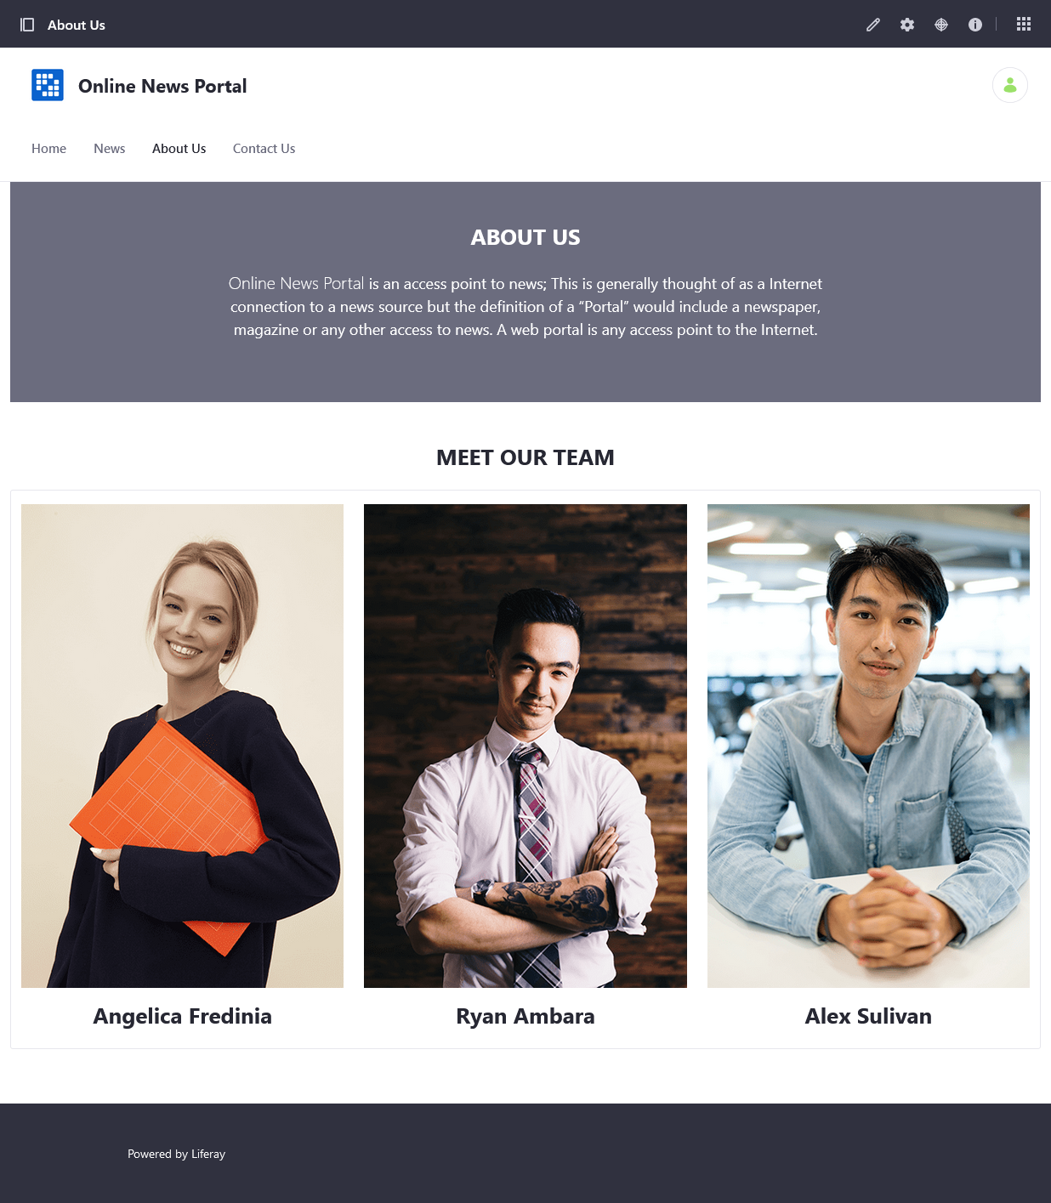

**Contact Us**

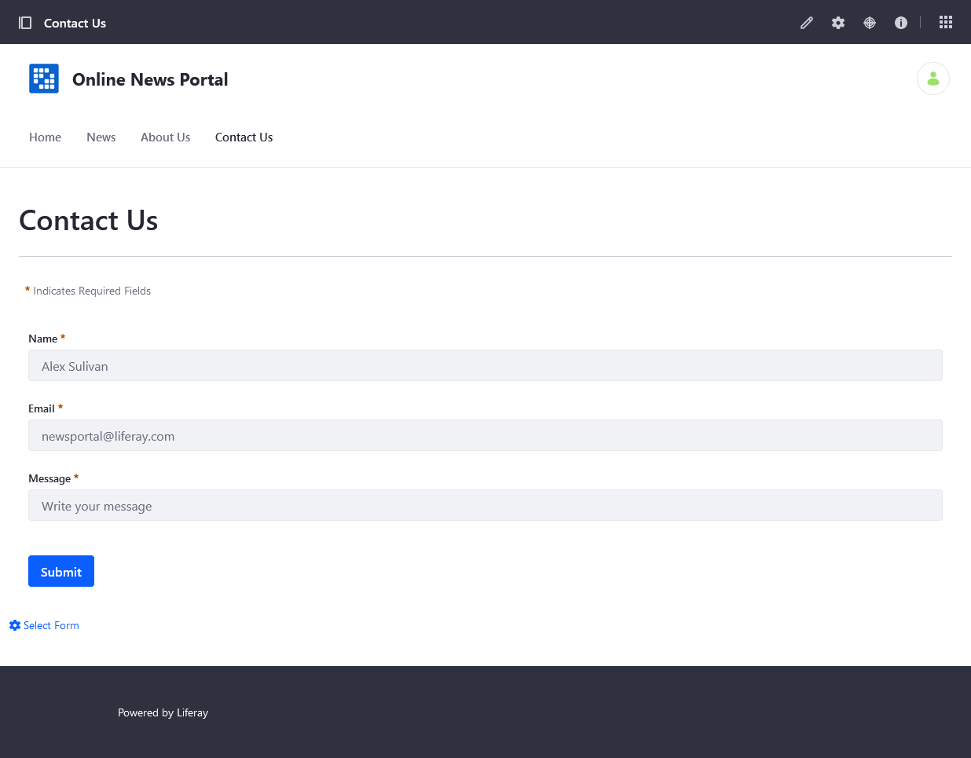

1. Create two blog posts with embed videos by using blog Feature.

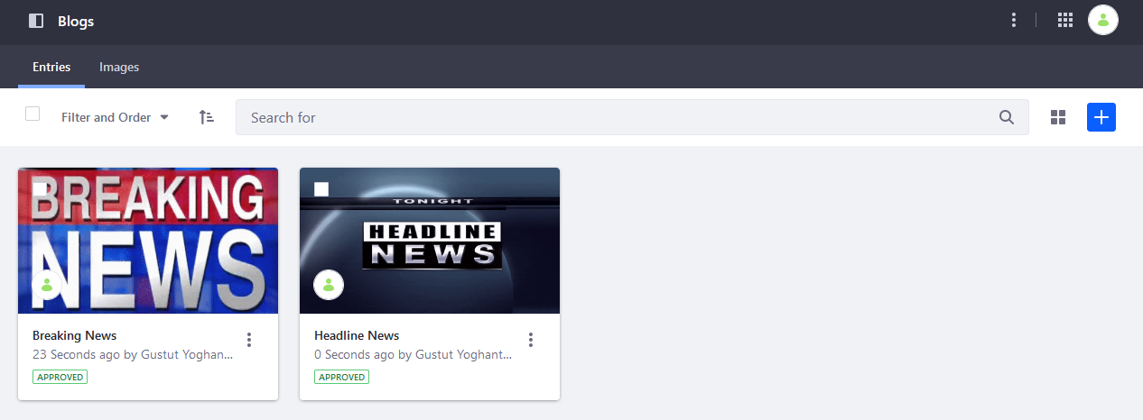

1. Create new “Application Display Template - ADT” developed with *Velocity* or *Free Marker Template* and enable it for changing the blog posts display dynamically.

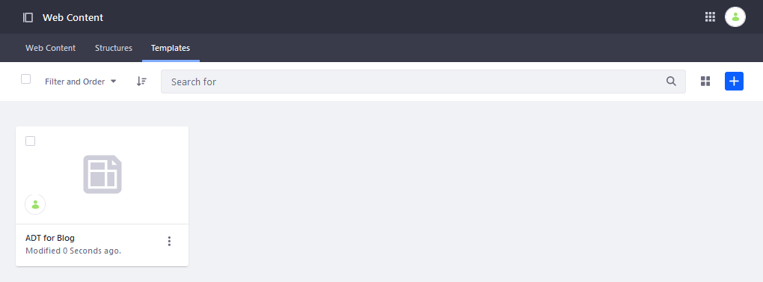

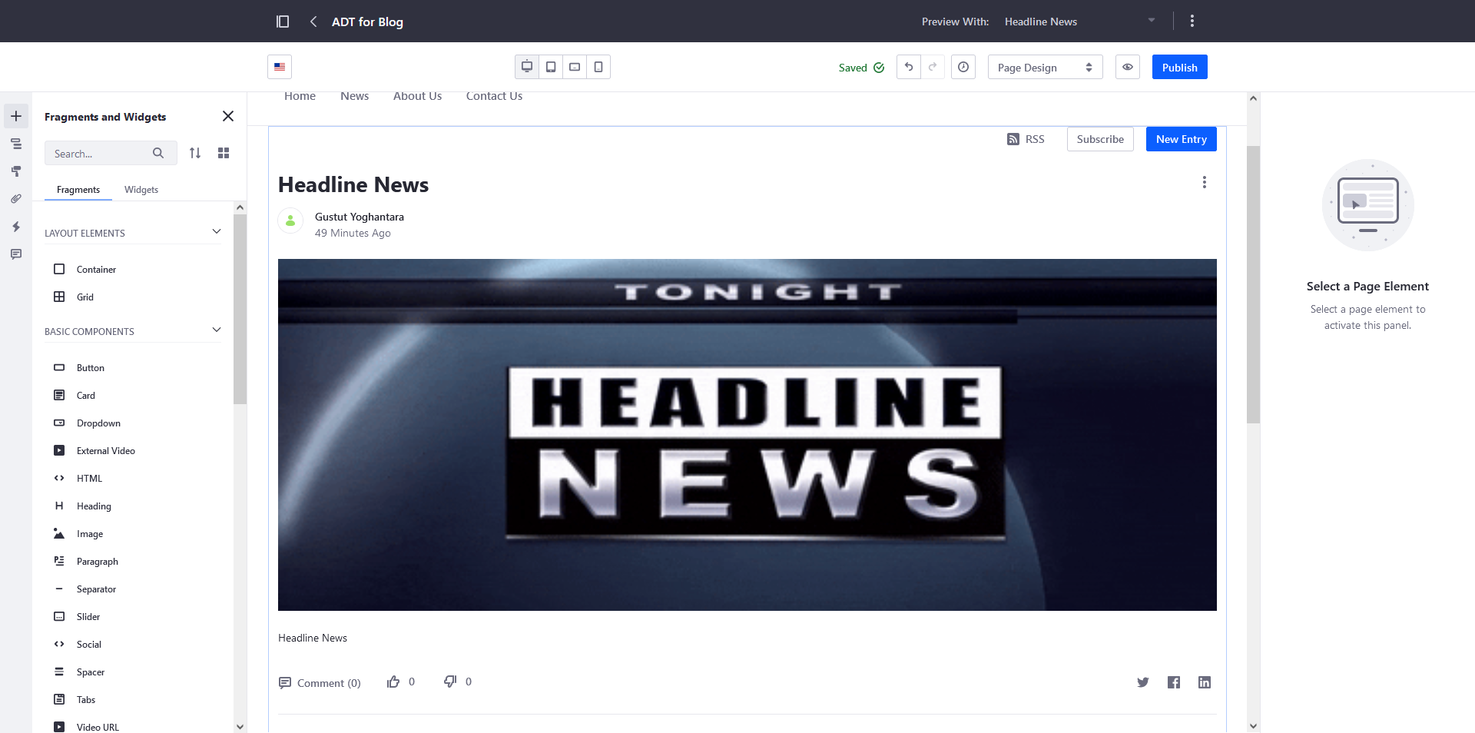

1. Create "Page Template" with "Web Content" portlet.

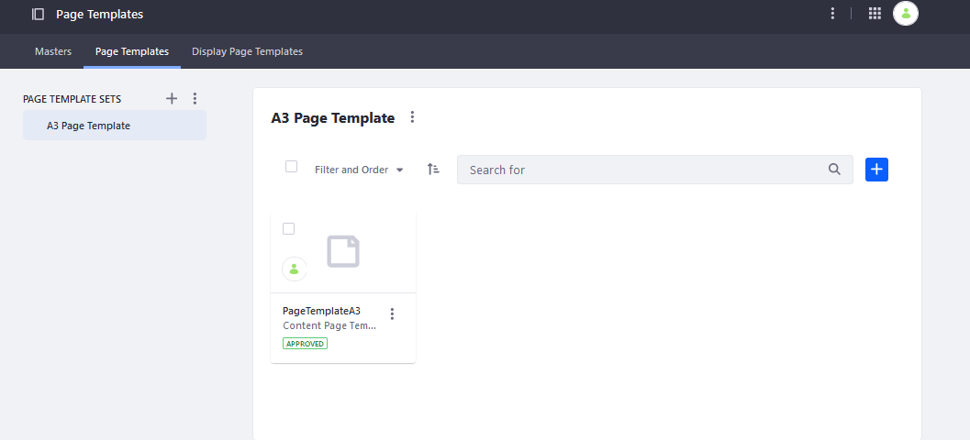

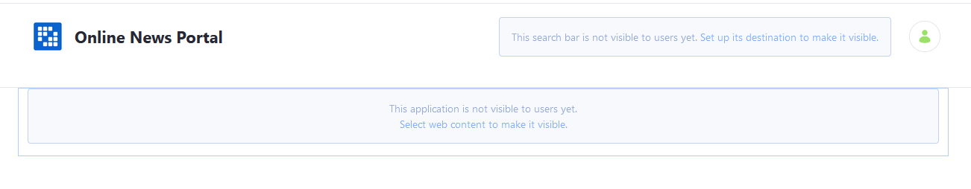

1. Apply Page Template in About us and Contact us Pages.

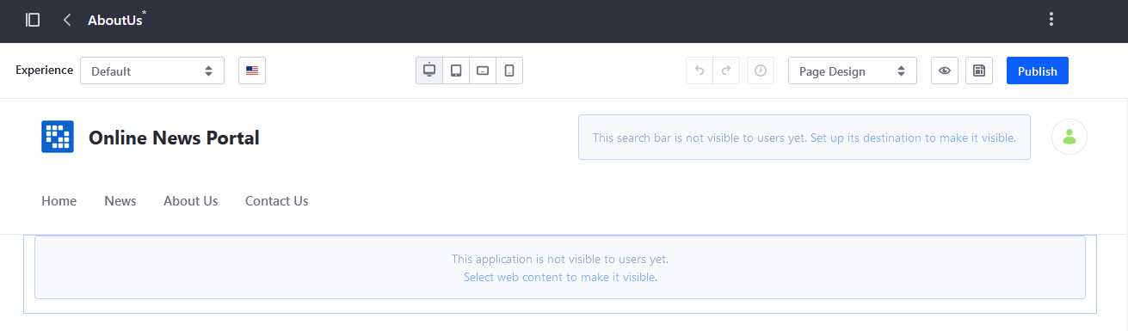

1. Adding an application portlet into Home, News, About Us and Contact Us pages.  
   **Home**  
   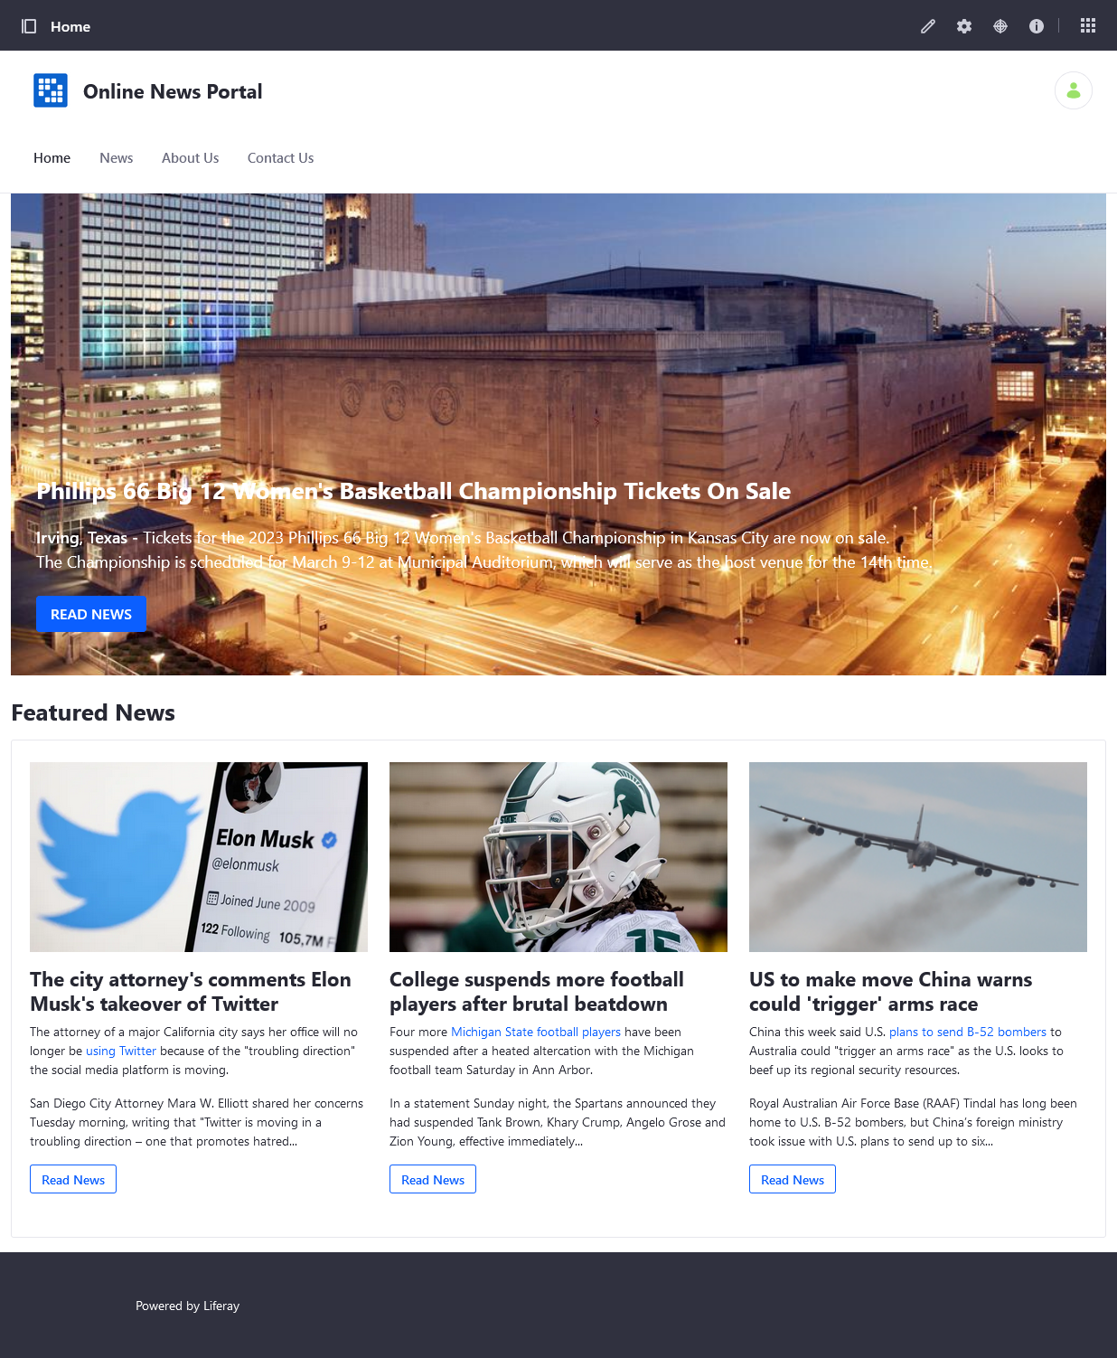

**News**

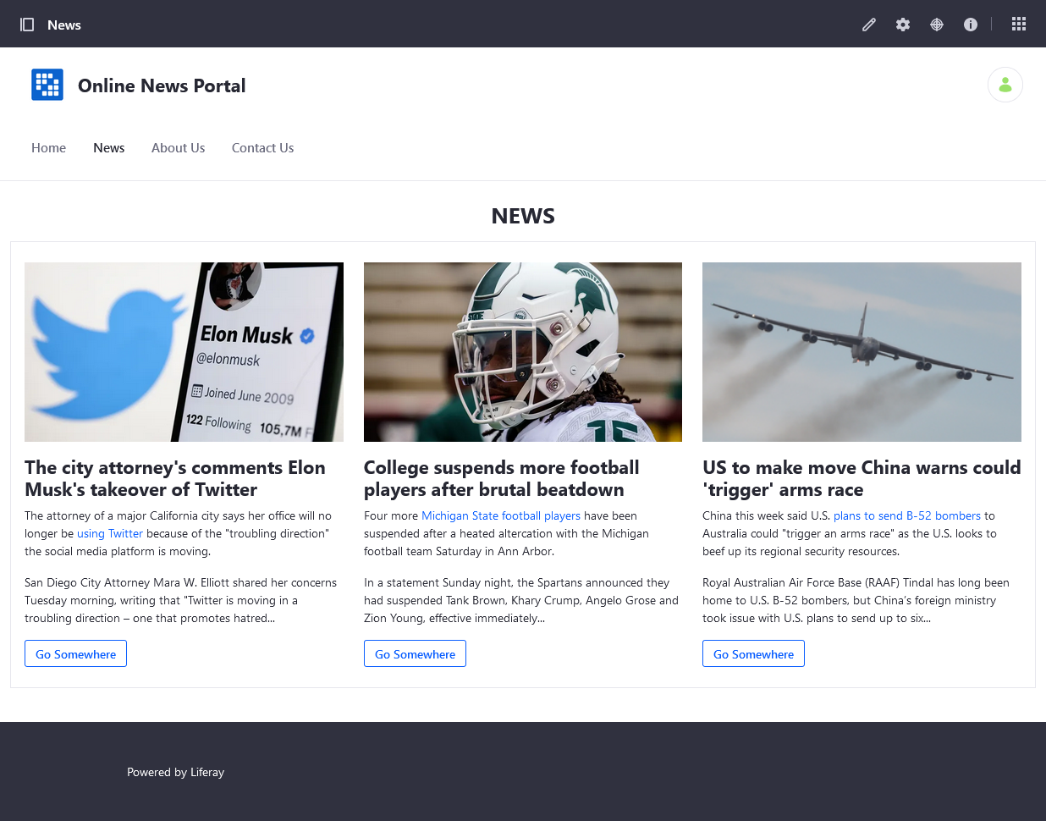

**About Us**



**Contact Us**

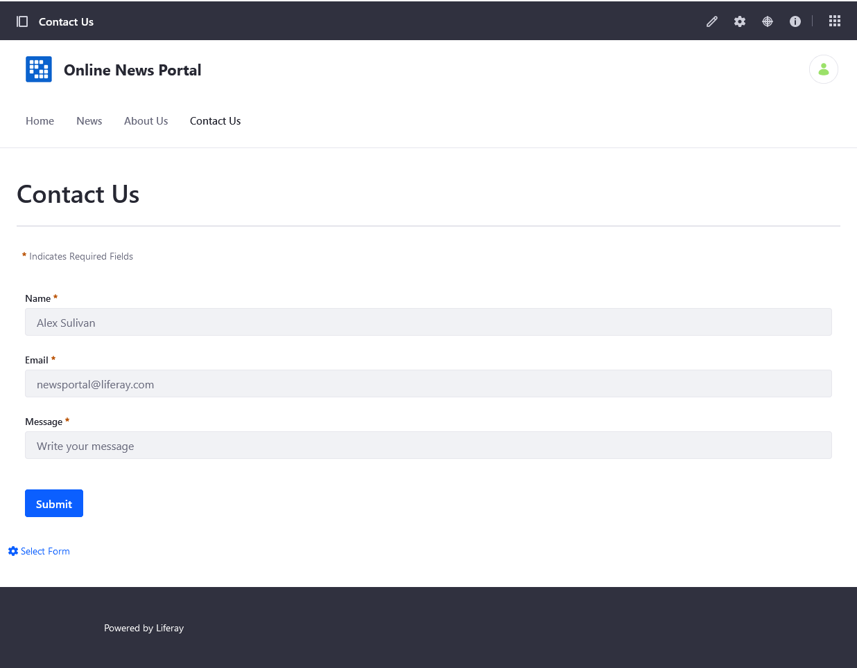

1. Update your "welcome" and other portlet design via from Look and Feel tab.

